

**ONLINE BANKING SYSTEM**

**(SOHOJ Banking)**

**Software Project-2**

**Submitted By**

|  |  |
| --- | --- |
| **ID** | **NAME** |
| **15-30923-3** | **Sandhi, Shihab Rizwan** |
| **15-30854-3** | **Parves, Rubel** |
| **16-31557-1** | **Saha, Saikat Chandra** |
| **16-31429-1** | **Chowdhury, Md Faisal** |

**Department of Computer Science**

Faculty of Science & Technology

**American International University – Bangladesh**

**27th August 2019**

**DECLARATION**

This is to certify that this project is our original work. No part of this work has been submitted elsewhere partially or fully for the award of any other degree or diploma. Any material reported in this project has been properly acknowledged.

________________________ __________________________

**Sandhi, Shihab Rizwan**

**15-30923-3**

**Rubel Parves**

**15-30854-3**

**SE**

**CIS**

_____________________

**Saha,Saikat Chandra**

**16-31557-1**

__________________________

**Chowdhury, Md Faisal**

**16-31429-1**

**CIS**

**CIS**

**APPROVAL**

The project titled “**Online Banking (Sohoj Banking)**” has been submitted to the following respected members of the board of examiners of the Department of Computer Science, American International University – Bangladesh [AIUB] in partial fulfillment of the requirements for the degree of Bachelor of Science in Computer Science and Software Engineering on 28 September 2019 has been accepted as satisfactory.

|  |  |
| --- | --- |
| _______________________________  **MD.EZAZUL ISLAM**  Assistant Professor & Supervisor  Department of Computer Science  American International University-Bangladesh | _______________________________  **SABBIR AHMED**  Assistant Professor & External  Department of Computer Science  American International University-Bangladesh |
|  |  |
| _______________________________  **DR. M. M. MAHBUBUL SYEED**  Associate Professor and Head [UG Program]  Department of Computer Science  American International University-Bangladesh | _______________________________  **Professor Dr. Tafazzal Hossain**  Dean  Faculty of Science & Information Technology  American International University-Bangladesh |
|  |  |
| _______________________________  **Dr. Carmen Z. Lamagna**  Vice Chancellor  American International University-Bangladesh | |

**ACKNOWLEDGEMENT**

This project is the result of our cordial effort and our supervisor’s initiative and constant motivation. But first of all we would like to be grateful to the Almighty GOD, Who gives us the effort to work on this project. Special thanks go to our honorable supervisor MD Ezazul Islam, Assistant Professor, American International University – Bangladesh [AIUB]. His excellent supervision and constant support makes this project possible. We also want to thank our Vice Chancellor Dr. Carmen Z. Lamagna, our Dean Prof. Dr. Tafazzal Hossain, our Associate Dean-In-Charge, Mr. Mashiour Rahman, and our Head of Department Dr. M. M. Mahbubul Syeed for their constant motivation and support.

**TABLE OF CONTENT**

|  |  |  |
| --- | --- | --- |
|  | Project Summary…………………………………………………………….. | 9 |
|  | **Chapter 1** |  |
| 1 | Introduction………………………………………………………………….. | 10 |
| 1.1 | Overview…………………………………………………………………….. | 10 |
| 1.2 | Proposal……………………………………………………………………… | 10 |
| 1.3 | Motivation …………………………………………………………………... | 10 |
| 1.4 | Objectives……………………………………………………………………. | 10 |
| 1.5 | Software Application Usability ……………………………………………... | 11 |
| 1.6 | Types of User………………………………………………………………... | 11 |
| 1.7 | Features……………………………………………………………………… | 11-12 |
|  | **Chapter 2** |  |
| 2 | Requirement Analysis…………………………………………………………. | 13 |
| 2.1 | Stakeholders…......………………………………………………………….... | 13 |
| 2.2 | Use case Diagram…………………………………………………………….. | 13 |
| 2.3 | Requirement Specification…………………………………………………… | 14 |
| 2.3.1 | Customer Requirement……………………………………………………….. | 14 |
| 2.3.2 | Architectural Requirement …………………………………………………... | 14 |
| 2.3.3 | Performance Requirement……………………………………………………. | 15 |
| 2.4 | Cost BenefitAnalysis…………………………………………………………. | 15-17 |
| 2.5 | Return of Investment…………………………………………………………. | 17 |

|  |  |  |
| --- | --- | --- |
|  | **Chapter 3** |  |
| 3 | Software Design…….………………………………………………………………. | 18 |
| 3.1.1 | Activity Diagram …………………………………………………….....…………... | 18-20 |
| 3.2.1 | Statechart Diagram for Admin | 21-22 |
| 3.3 | Entity Relationship Diagram …………………………………….…………………. | 23 |
|  | **Chapter 4** |  |
| 4 | STATEMENT OF WORK………………………………………………………….. | 24 |
| 4.1 | Development Objectives …………………………………………………………… | 24 |
| 4.2 | Scope …………………………………………………........……………………….. | 24 |
| 4.3 | Hypothesis……………………………………………………………....................... | 24 |
| 4.4 | Environment………………………………………………………………………… | 24 |
| 4.5 | Challenges………………………………….……………………………………….. | 24 |
| 4.6 | Screenshots of Project………………………………………………………………. | 25 |
| 4.6.1 | Admin Panel………………………………………………………………………… | 25-28 |
| 4.6.2 | Customer Panel …………………………………………………………………….. | 29-33 |
| 4.6.3 | Staff Panel…………………………………………….…………………………….. | 33-35 |
|  | **Chapter 5** |  |
| 5 | Literature Study……………………………………………………………………... | 36 |
| 5.1 | Description of similar Existing Systems……………………………………………. | 36 |
| 5.2 | Feature/Performance Gap with Existing System …………………………………... | 36-37 |
| 5.3 | Comparison chart……………………………………………………………………. | 38 |
| 5.4 | External resources required so far…………………………………………………… | 38 |
|  | **Chapter 6** |  |
| 6 | Development Process………………………………………………………... | 39 |
| 6.1 | Methodology of development……………………………………………………….. | 39 |
| 6.2 | Developed Source Code Specification………………………………………………. | 39 |
|  | **Chapter 7** |  |
| 7 | Progress So Far…………………………………………………………………….. | 40 |
| 7.1 | Discussion on outcome……………………………………………………………… | 40 |
| 7.2 | Performance Progress……………………………………………………………….. | 40 |
| 7.3 | Findings…………………………………………………………………………… | 40 |
| 7.4 | Future Aspects …..……………………………………………………….………… | 40 |
| 7.5 | Conclusion …………………………………………………………………………... | 41 |
|  | **Chapter 8** |  |
| 8 | REFERENCES……………………………………………………………………… | 41 |

**LIST OF FIGURES**

|  |  |  |
| --- | --- | --- |
| Figure-1 | **This is a figure of Use Case Diagram for Online Banking**……..………… | 13 |
| Figure-2 | **This is a figure of Activity Diagram for Admin**……………………………. | 18 |
| Figure-3 | **This is a figure of Activity Diagram for Customer**…………………..…….. | 19 |
| Figure-4 | **This is a figure of Activity Diagram for Staff**…………..................………... | 21 |
| Figure-5 | **Statechart Diagram for Admin**……………………………………………… | 21 |
| Figure-6 | **Statechart Diagram for Customer**…………………………………………... | 21 |
| Figure-7 | **Statechart Diagram for Staff**………………………………………………… | 22 |
| Figure-8 | **This is a figure of E-R Diagram for Online Banking**….…………………… | 23 |
| Figure-9 | **This is a figure for Home page**………………………………………………. | 25 |
| Figure-10 | **This is a figure for Admin Options**………………………………………….. | 25 |
| Figure-11 | **This is a figure for Admin Adding Customer Sign Up**…………………….. | 26 |
| Figure-12 | **This is a figure for Admin Adding Staff** …….........………………………… | 26 |
| Figure-13 | **This is a figure for Admin Editing Customer** .......................………………. | 27 |
| Figure-14 | **This is a figure for Admin Deleting Customer** …………………………….. | 27 |
| Figure-15 | **This is a figure for Editing staff**.........……………………………………….. | 28 |
| Figure-16 | **This is a figure for deleting staff**……………………………………………... | 28 |
| Figure-17 | **This is a figure for Customer options**……………………………………….. | 29 |
| Figure-18 | **This is a figure for customer personal details**……………………………… | 29 |
| Figure-19 | **This is a figure for customer password changing**………………………..... | 30 |
| Figure-20 | **This is a figure for customer cheque book and ATM request**…………… | 30 |
| Figure-21 | **This is a figure for customer account statement**…………………………… | 31 |
| Figure-22 | **This is a figure for customer mini account statement**……………………... | 31 |
| Figure-23 | **This is a figure for customer add Beneficiary**……………………………… | 32 |
| Figure-24 | **This is a figure for customer fund transfer**………………………………… | 32 |
| Figure-25 | **This is a figure for customer to view or delete Beneficiary**……………….. | 33 |
| Figure-26 | **This is a figure for staff options**……………………………………………... | 33 |
| Figure-27 | **This is a figure for staff password change**………………………………….. | 34 |
| Figure-28 | **This is a figure for customer approval………………………………………** | 34 |
| Figure-29 | **This is a figure for customer’s atm approval……………………………….** | 35 |
| Figure-30 | **This is a figure for customer’s Beneficiary approval………………………** | 35 |
| Figure-31 | **This is a figure for customer’s cheque book approval.......……………….** | 35 |

**LIST OF TABLES**

|  |  |  |
| --- | --- | --- |
| Table-1 | **This is a table of Cost Benefit Analysis**………………………………. | 15-16 |
| Table-2 | **This is a table for Return of Investment** …………………………….. | 17 |
| Table-3 | **This is a table of Comparison Chart**…………………………………. | 38 |

|  |
| --- |
| **PROJECT SUMMARY** |

Online banking, also known as internet banking, is an electronic payment system that enables customers of a bank or other financial institution to conduct a range of financial transactions through the financial institution's website.Banking online or by phone allows you to make banking transactions such as transferring money, paying a bill, checking your balance or setting up a regular payment on your bank or building society's secure website. Online banking is accessible via a computer/tablet or a mobile phone. Also known as internet banking.E banking provides many advantages for banks and customer's .e-banking has made life much easier and banking much faster for both customers and banks. It provides banking throughout the year 24/7 days from any place have internet access. In addition to the advantages listed above many online accounts include features like online bill pay which helps you save time and money when paying bills. Many online banks also offer the convenience of checking your account information from your cell phone.

By online Banking you will get those features for use which is given below:

1. Use Popmoney
2. Use Bank-to-Bank Transfer.
3. See your account transactions and history
4. Pay bills without writing checks.
5. Transfer money between your accounts.
6. Sign up for paperless statements.
7. Set up account alerts and reminders.
8. View images of processed checks.

Online banking is safe when secure bank technology on the back end is met with alert consumers on the front end. As an account holder, you have a role in making sure accounts are protected. The email might suggest there's a problem with your account and ask for your bank password or Social Security number.

|  |
| --- |
| **Chapter 1 INTRODUCTION** |

**1.1 Overview**

This describes how the online Banking system defines the design specifications and what the system must do. It includes the following:

1. Concept formulation
2. Problem understanding.
3. Requirements proposals.
4. Feasibility study.
5. Architectural design.

**1.2 Proposal**

This software or Web Application is intended for implementing a dynamic online Banking system, so that a customer can easily access to our service and do online transactions. We call our project as **Sohoj Banking** which is an online Banking system can made a customer’s online transaction experience a little easier.

**1.3 Motivation**

Going to bank for any transaction is time consuming. The use of technology has increased. The features of internet banking are easy to use, privacy, secured, accessibility and so on. Hence, it is important to study the perception of customers in Bangladesh about the internet banking and the factors influencing their perception and what can be done to increase the adoption rate in the country. It is a motivational force that society is becoming cashless and people are very interested to using online Banking system.

**1.4 Objectives**

1. Transaction can do online
2. Consume time
3. User friendly
4. Up to date with latest services from that particular Bank.
5. Make simple, easy, and reliable the Banking transaction system.

**1.5 Software Application usability**

1. Secure customer privilege
2. User-Friendly system.
3. Only valid customers and bus bank organization can use the system
4. Customer, admin & staff have to sign up for using the system
5. Can cancel their transaction.
6. Customer can see their profile, status and update also.
7. Banking company can also updates details for customer

**1.6 Types of user:**

There will be three types of user:

1. Admin
2. Staff
3. Customer

**1.7 Product Features:**

This software/website will provide a number of functionalities. Each of them is stated below:

User type:

1. Admin
2. Stuff
3. Customer

**For registering to the system:**

1. New customer has to register.
2. Existing customer, admin, stuff have their unique mail id and password for login.

**After Login:**

**Customer Functionalities:**

1. Can show their profile.
2. Can withdraw money.
3. Can deposit money.
4. Can transfer money one bank to another bank or in that bank.
5. Can start fixed deposit.
6. Can update their profile.
7. Can change the password.
8. Log out from the system.
9. Can apply for credit/debit card.

**Staff Functionalities:**

1. Approve credit/debit card.
2. Approve new registration.
3. Send notification to the customer.
4. Can see the list of customer who did any transaction through system.
5. Change password.

**Admin Functionalities:**

1. Add new customer after approving by staff.
2. Show the list of all customers or search particular one.
3. Update/delete customer.
4. Can post article.
5. Can block any account for particular time period.
6. Can have access in customer profile.
7. Change password.
8. Logout.

**Extra Functionalities:**

1. Notification through email after each successful transaction.

|  |
| --- |
| **Chapter 2:REQUIREMENT ANALYSIS** |

**2.1 Stakeholders**

In this project major stakeholders are customers, banks, insurance companies, Finance companies, payment gateways and Government.

**2.2 Use case Diagram**

This use case diagram shows the relation between the admin, customer and staff. This diagram shows how an admin approve a customer. How staffs verify a customer and send transaction notification. This diagram shows how a customer can deposit, withdraw and transfer money.

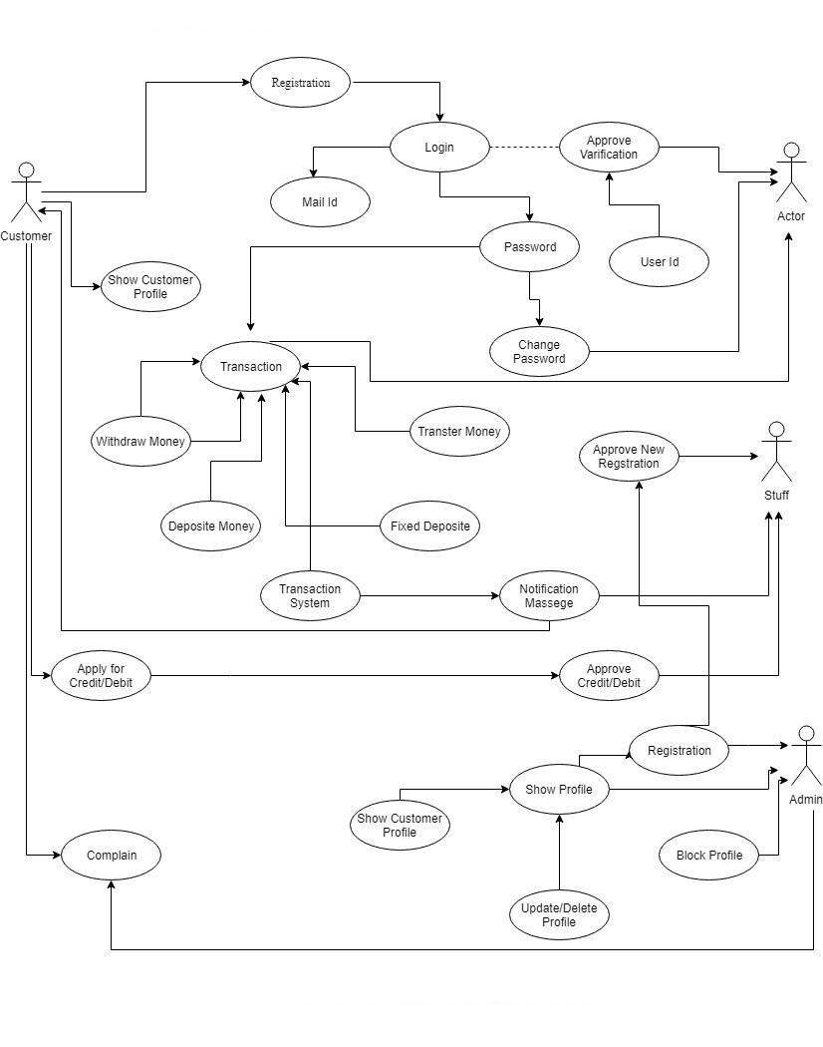

**Fig.1: Use Case Diagram for Online Banking**

**2.3 Requirement specification:**

**2.3.1 Customer Requirements:**

1. Can show their profile.
2. Can withdraw money.
3. Can deposit money.
4. Can transfer money one bank to another bank or in that bank.
5. Can start fixed deposit.
6. Can update their profile.
7. Can change the password.
8. Log out from the system.
9. Can apply for credit/debit card.

**2.3.2 Architectural Requirement:**

**Server Side:**

1. OS: Linux/Windows Server
2. CPU: Minimum Intel Xenon or higher
3. RAM: 4 GB or higher
4. Hard Drive: 1024 GB or more

**Client Side:**

1. Operating System: any operating system with webpage browsing accessibilities
2. CPU (PC): Minimum Intel Pentium or higher
3. Operating System (Android): any operating system with webpage browsing accessibilities
4. CPU (Android): Mali-400MP4 or higher
5. RAM: 512 mb or higher

**2.3.3 Performance Requirement:**

The system should be less time consuming with the operations. Majority of the works should be done internally during the program’s run-time. Then it should be set for network access.

**2.4 Cost Benefit Analysis:**

Domain cost is Tk. 1000/Year

**Package:**

**Web Space:** Unlimited*

**Bandwidth:** Unlimited*

**Databases:** Unlimited*

**Mailboxes:** Unlimited*

**FTP Accounts:** Unlimited*

**Free SSL certificate:**

Tk. 10000/year

Working Hours=8 hours per day

Working Days=22 days per month

**Salary:**

Project Manager(PM) = 70000 tk

Business Analyst(BA) = 50000 tk

Developer(D) = 50000 tk

Quality Tester(QT) = 50000 tk

**Man hour cost:**

**For project manager:**

Table cost = 3000 tk per month

Computer cost = 5000 tk per month

Other cost = 2500 tk

Per hour cost = ((70000+3000+5000+2500)/22)/8

= 457.39 tk

**For Business Analyst:**

Table cost = 2000 tk per month

Computer cost = 4000 tk per month

Other cost = 2500 tk

Per hour cost = ((50000+2000+4000+2500)/22)/8

= 332.39 tk

**For Developer:**

Table cost = 2000 tk per month

Computer cost = 5000 tk per month

Other cost = 2500 tk

Per hour cost = ((50000+2000+5000+2500)/22)/8

= 338.07 tk

**For Quality Tester:**

Table cost = 2000 tk per month

Computer cost = 5000 tk per month

Other cost = 2500 tk

Per hour cost = ((50000+2000+5000+2500)/22)/8

= 338.07 tk

|  |  |
| --- | --- |
| **Man hour cost:** |  |
| PM | 457.39 tk |
| BA | 332.39 tk |
| Developer | 338.07 tk |
| QT | 338.07 tk |

|  |  |  |  |
| --- | --- | --- | --- |
| **Requirement specification & design:** | | | |
| Position | Man hour | cost | Total |
| PM | 16 | 457.39 | 7318.24 |
| BA | 24 | 332.39 | 7977.36 |
|  |  | **Total cost** | **15295.6** |

|  |  |  |  |
| --- | --- | --- | --- |
| **Coding & testing:** | | | |
| Position | Man hour | cost | Total |
| PM | 30 | 457.39 | 13721.7 |
| BA | 50 | 332.39 | 16619.5 |
| Developer | 200 | 338.07 | 67614.0 |
| QT | 150 | 338.07 | 50710.5 |
|  |  | **Total cost** | **148665.7** |

**Total cost:**

Requirement specification & design =15295.6

Coding & testing =148665.7



**Total Cost = 163961.3 tk**

|  |  |
| --- | --- |
| **Estimated grand total cost** |  |
| **Description** | **Cost Assumption** |
| Site launch (hosting) | 30,000 BDT |
| Maintenance (1 year) | 50,000 BDT |
| Development | 163,961 BDT |
| **Grand total** | **243,961 BDT** |

**2.5 Return of Investment:**

|  |  |  |
| --- | --- | --- |
| **Year** | **Medium** | **Amount** |
| 1st | Service Charge + Third party Ad | 10,000.00 Tk |
| 2nd | Service Charge + Third party Ad + Merchant Commission | 25,000.00 Tk |
| 3rd | Service Charge + Third party Ad + Merchant Commission | 45,000.00 Tk |
| 4th | Service Charge + Third party Ad + Merchant Commission | 75,000.00 Tk |
| 5th | Service Charge + Third party Ad + Merchant Commission | 1,00,000.00 |
| **After 5 years** | **Total=** | **2,55,000.00** |

**To return the investment it will take 5 years.**

|  |
| --- |
| **CHAPTER 3: SOFTWARE DESIGN** |

**3.1.1 Activity Diagram for Admin:**

An admin approve a customer. Can delete a customer. Can view customer list. Can update, delete and block a customer.

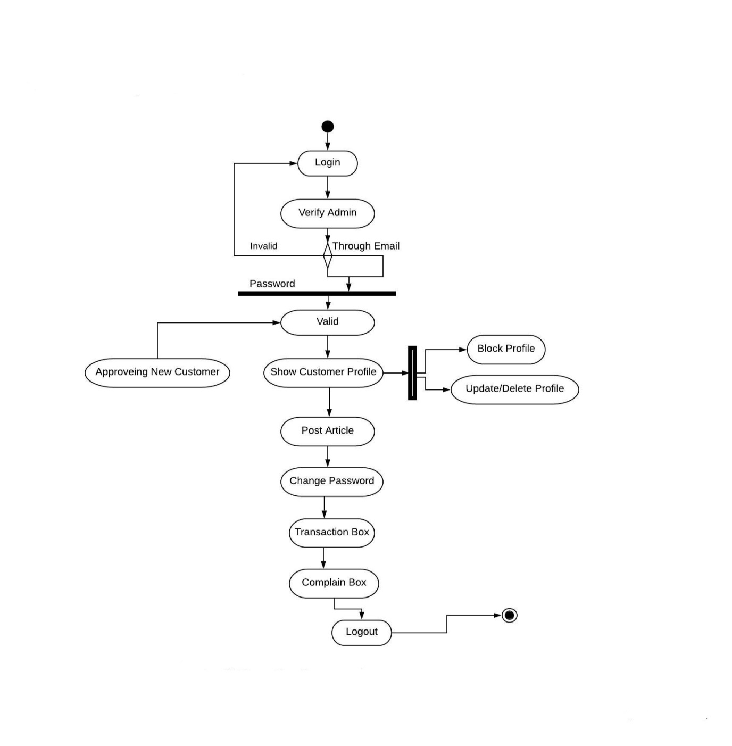

**Fig.2: Activity Diagram for Admin**

**3.1.2 Activity Diagram for Customer:**

A customer can login and transact money. A customer can also add Debit/credit card. Can change password and update profile. A customer can deposit, withdraw and transfer money.

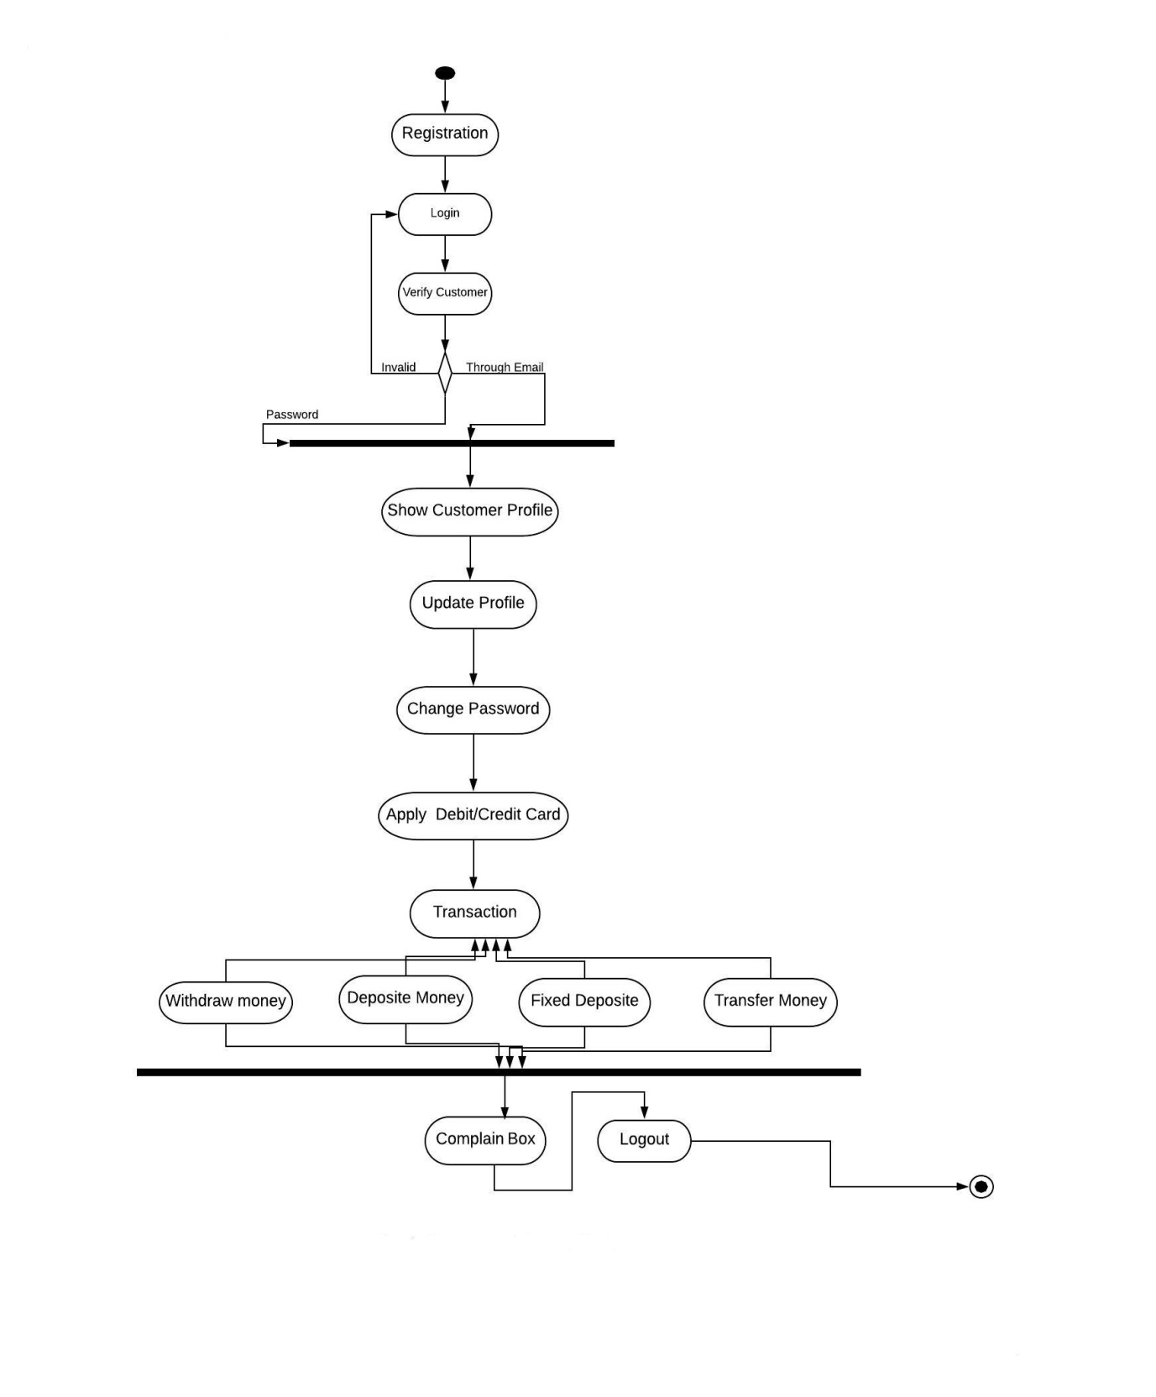

**Fig.3: Activity Diagram for Customer**

**3.1.3 Activity Diagram for Staff:**

Staff approves new registration and sends transaction notification to the customer.

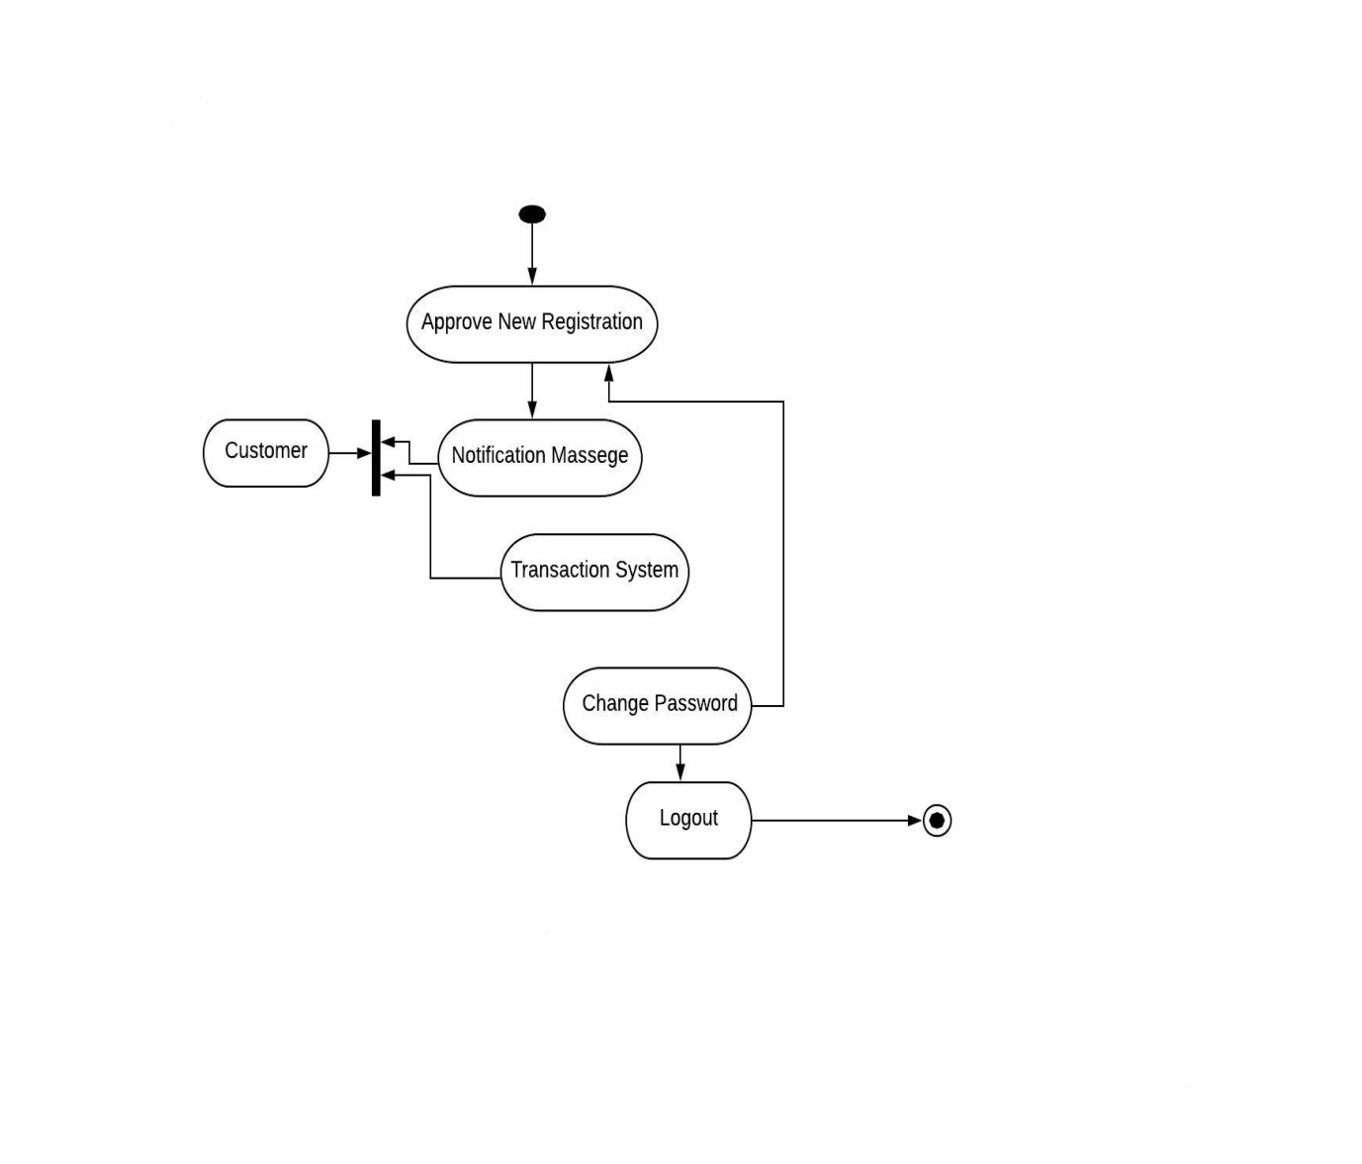

**Fig.4: Activity Diagram for Staff**

**3.2.1 Statechart Diagram for Admin:**

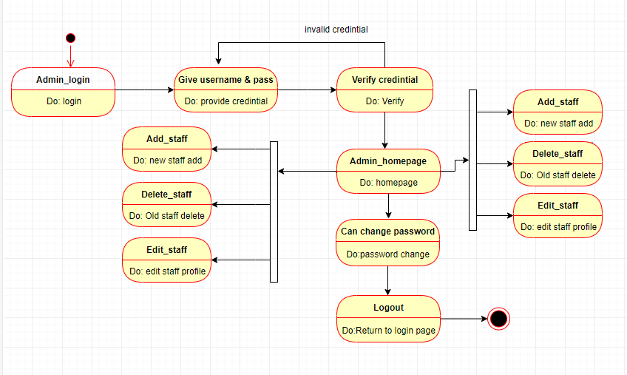

**Fig.5: Statechart Diagram for Admin**

* + 1. **Statechart Diagram for Customer:**

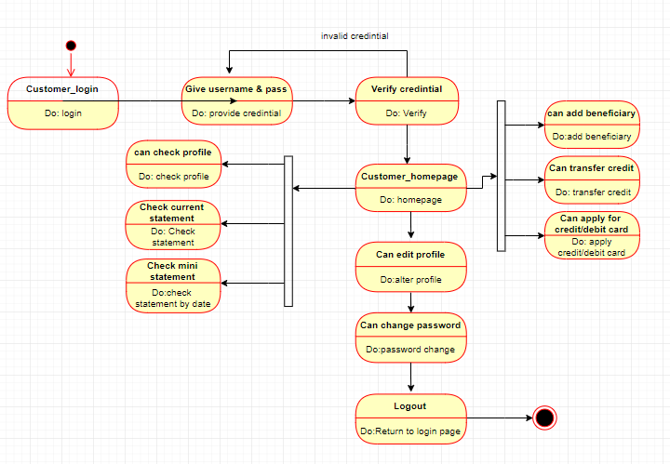

**Fig.6: Statechart Diagram for Customer**

**3.2.3 Statechart Diagram for Staff:**

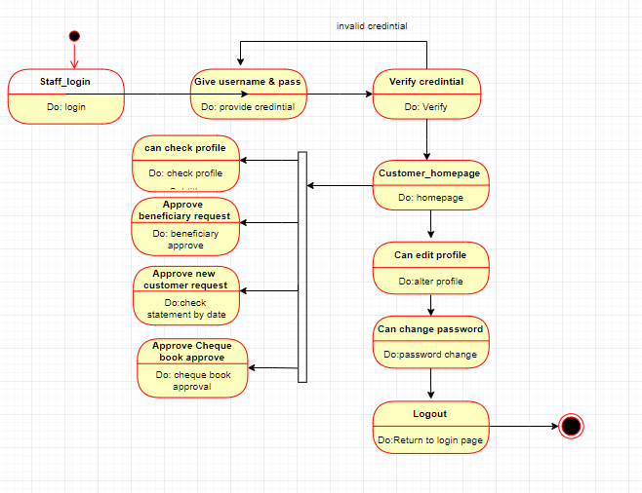

**Fig.7: Statechart Diagram for Staff**

**3.3 ER Diagram for Online Banking**

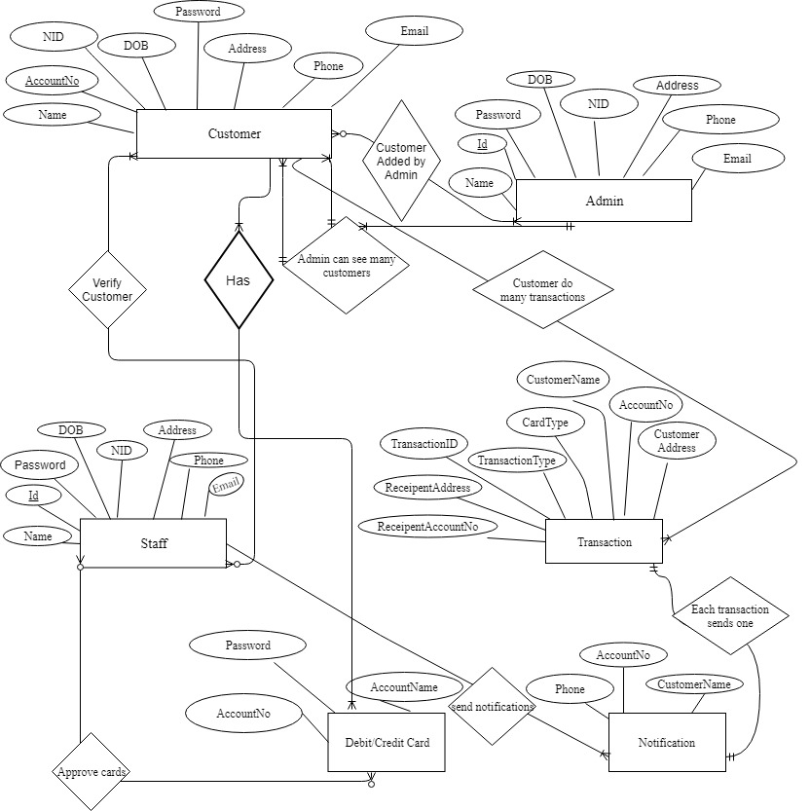

**Fig.8: ER Diagram for Online Banking System**

|  |
| --- |
| **CHAPTER 4**: **STATEMENT OF WORK** |

**4.1** **Development Objective:**

The main objective of the document is to describe the requirement of the project ―Online Banking‖. The documentation gives the detailed description of the both functional and nonfunctional requirement for this. The document is developed after a number of studying the requirement specification paper of the given project. The final products of the team will be meeting the requirements of the document.

**4.2 Scope:**

The project is designed to run on desktop and mobile applicaton as well. User uses this application to save time and they can do online banking ticket form home through online easily.

**4.3 Hypothesis:**

1. People is not happy with existing banking system

2. Advancement of technology demands cashless society

**4.4 Environment:**

The website must work in any android, IOS. The customers, admins and staffs must be able to access the website from any web browser which must include Google chrome, Mozilla Firefox and Internet Explorer

**4.5 Challenges:**

1. The most impactful barrier of online banking is security
2. The next challenge is customer’s privacy
3. Broadband speed is another barrier of online banking
4. Sophisticated IT infrastructure
5. Lack of IT knowledge
6. Require mobile or computers to use
7. Customer satisfaction

**4.6 Screenshots of Project:**

**4.6.1 Admin Panel:**

This is the home page of our Online Banking (Sohoj Banking).

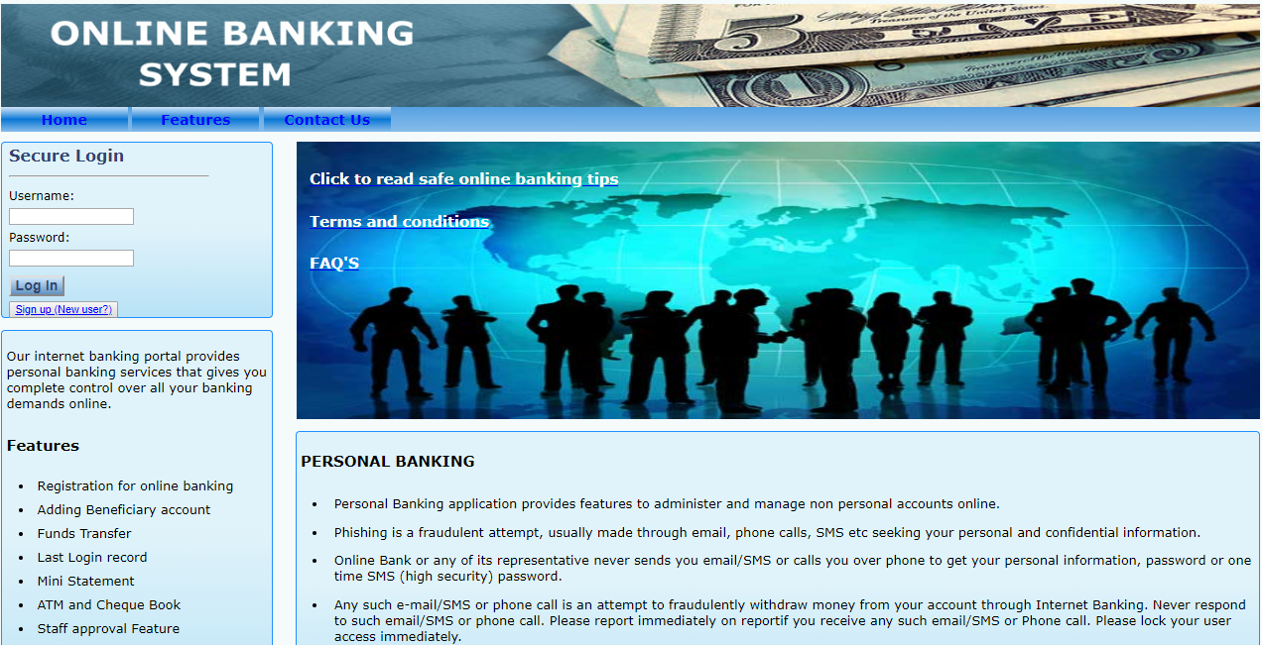

**Fig.9: Home page**

**Admin Options:** After login admin will have these options for their doing their banking activities. Here, an admin can change his/her password. An admin can add, delete and edit a customer or staff.

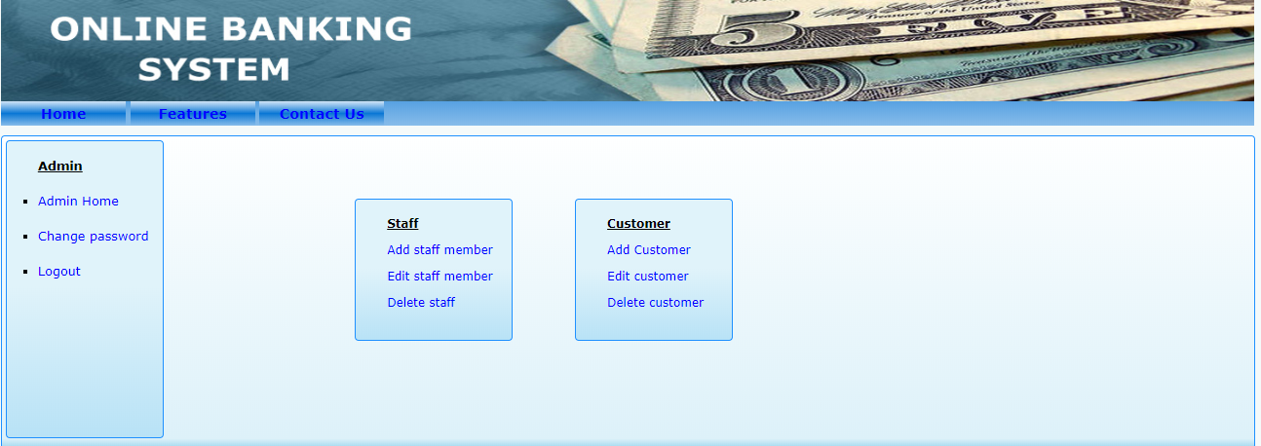

**Fig.10: admin options**

**Admin Adding Customer:** By fill up new customer name, Password, Mobile number, Address etc then confirm. By this new customer can be added.

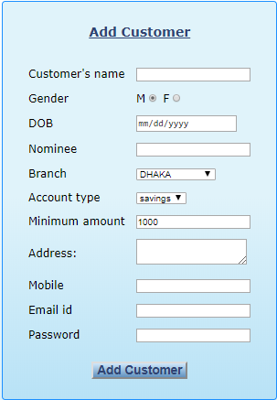

**Fig.11: This is a figure for Customer SignUp**

**Admin Adding Staff:** After login to the system an admin can add staff to the system 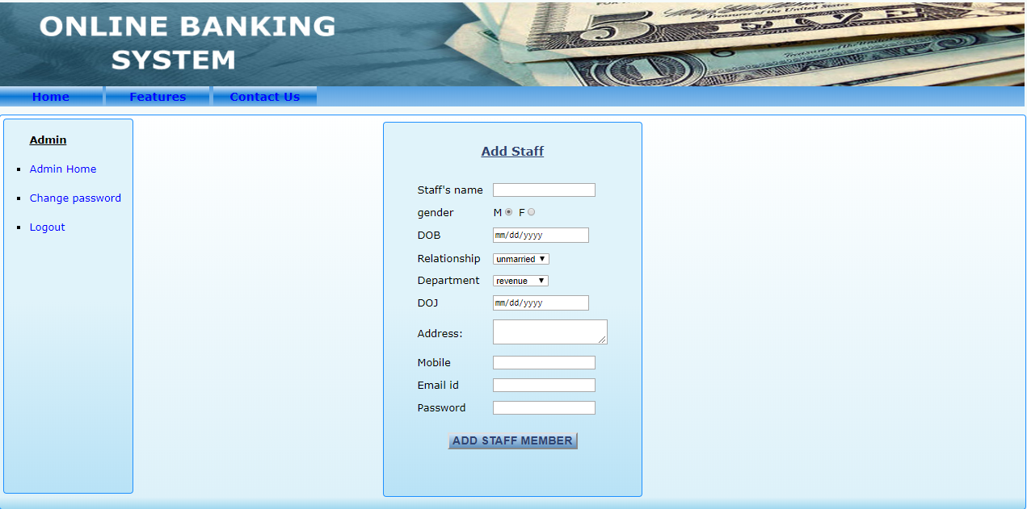

**Fig.12: This is a figure for Adding Staff**

**Admin Editing Customer:** Here, an admin can edit customers information

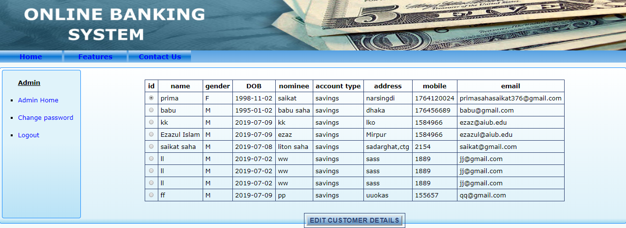

**Fig.13: This is a figure for Editing Customer**

**Admin Deleting Customer:** Here, an admin can delete a customer.

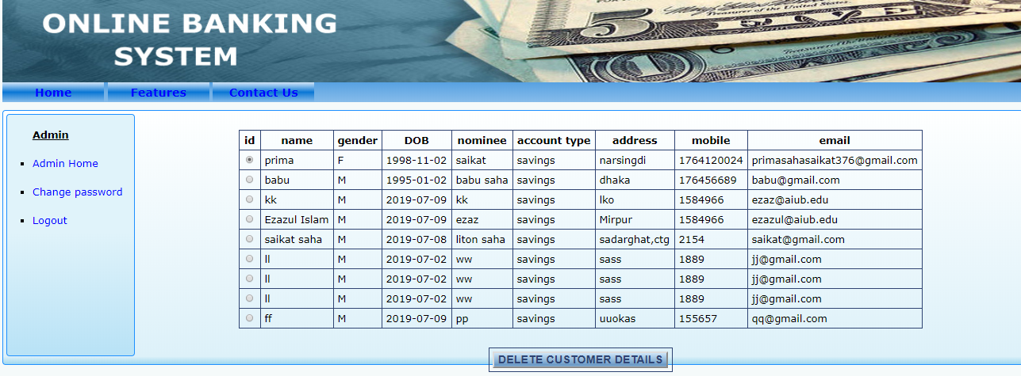

**Fig.14: This is a figure for Deleting Customer**

**Admin Editing Staff:** Here, an admin can edit staff’s information

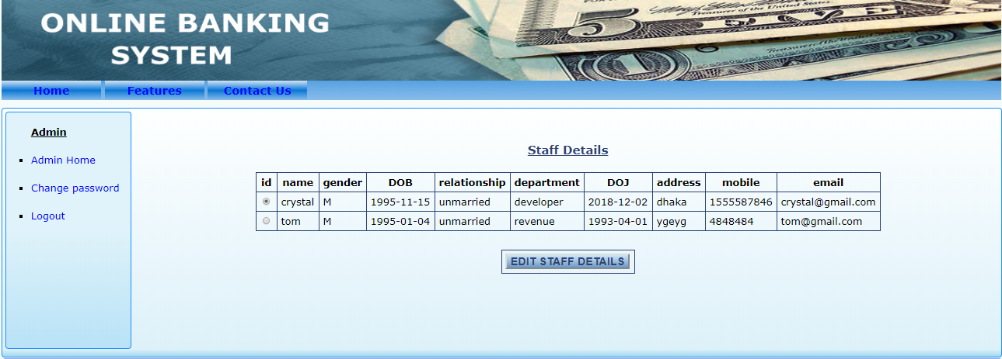

**Fig.15: This is a figure for Editing Staff**

**Admin Deleting Staff:** An admin can delete a staff after login to admin panel

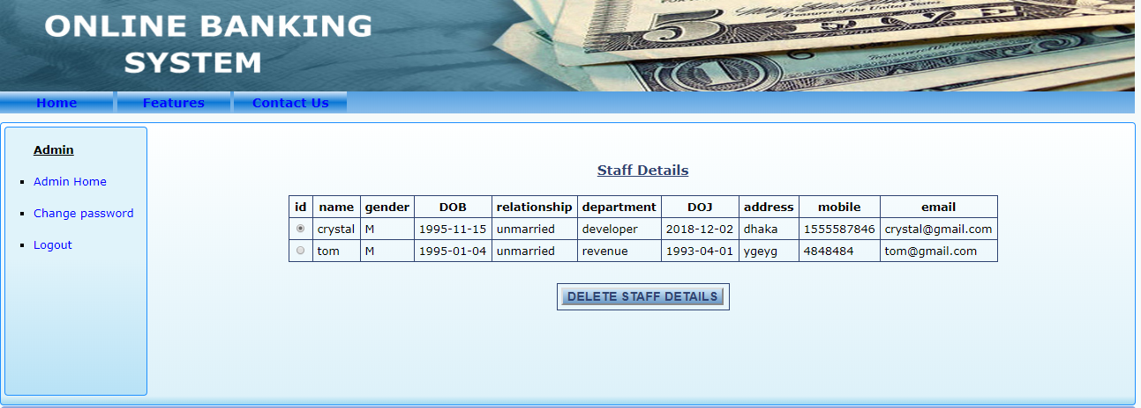

**Fig.16: This is a figure for Deleting Staff**

**4.6.2 Customer Panel:**

**Customer Options:** After login customer will have these options for their transaction and many more. Here, customer can see account balance, can transfer money, can pay bill.

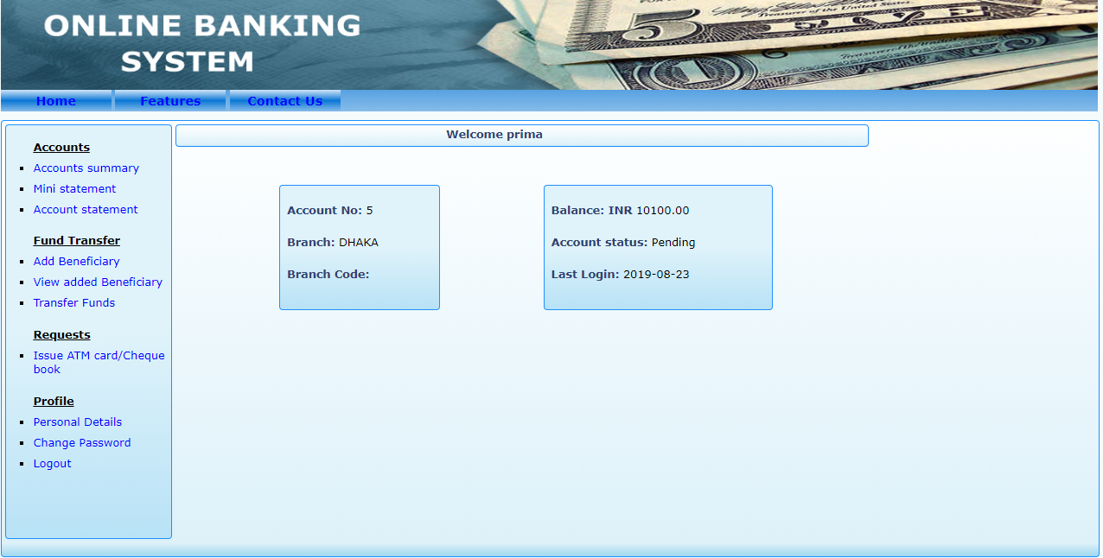

**Fig.17: Customer’s Option**

**Customers Personal Details:** Here, a customer can see his/her personal details.

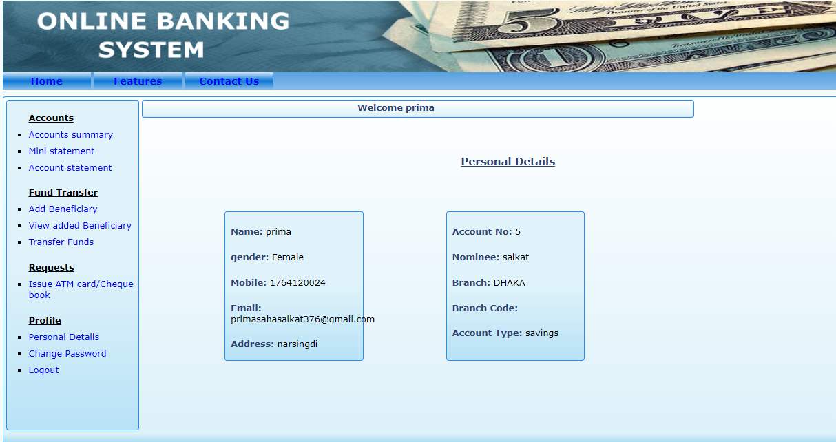

**Fig.18: Customer’s personal details**

**Customer Changing Password:** Here, a customer can change his/her password.

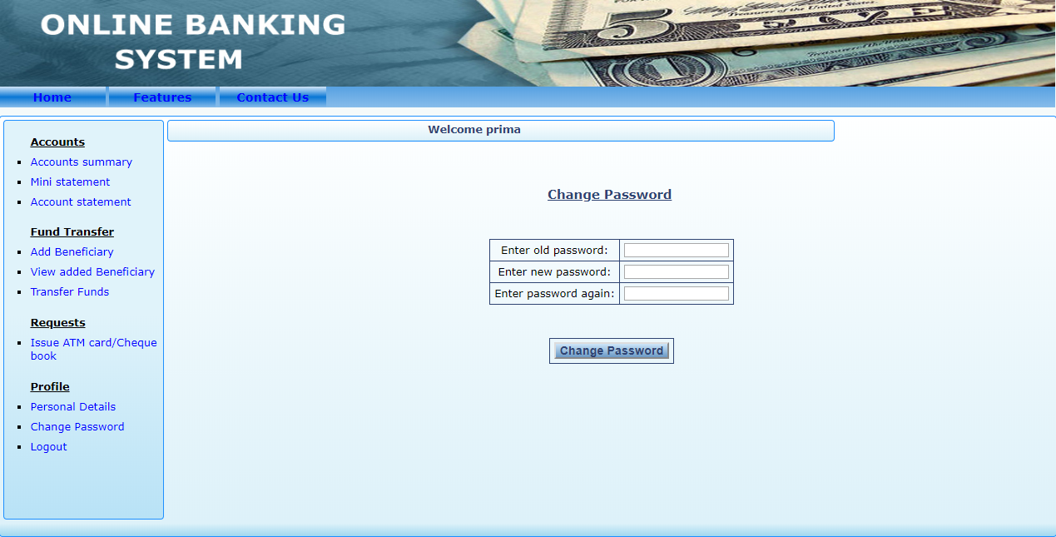

**Fig.19: Customer’s password changing**

**Customer’s Cheque Book and ATM Request:** Here, a customer can request request for a cheque book.

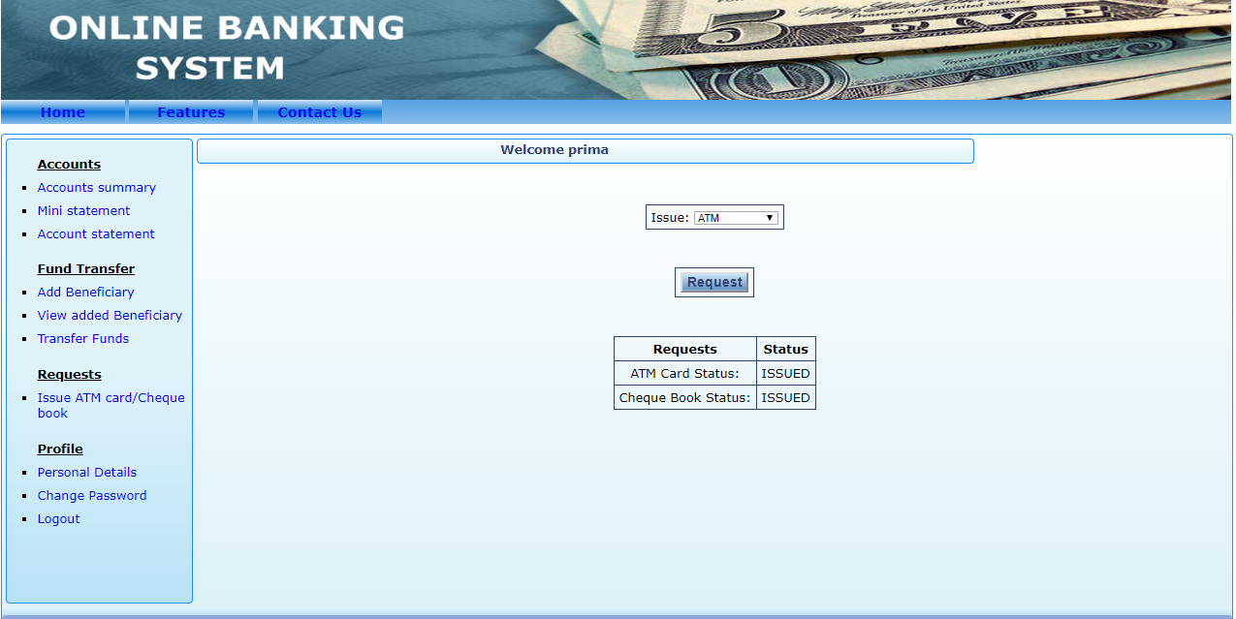

**Fig.20: Customer’s cheque book and ATM request**

**Customer’s Account Statement:** From here, customer can see account statement.

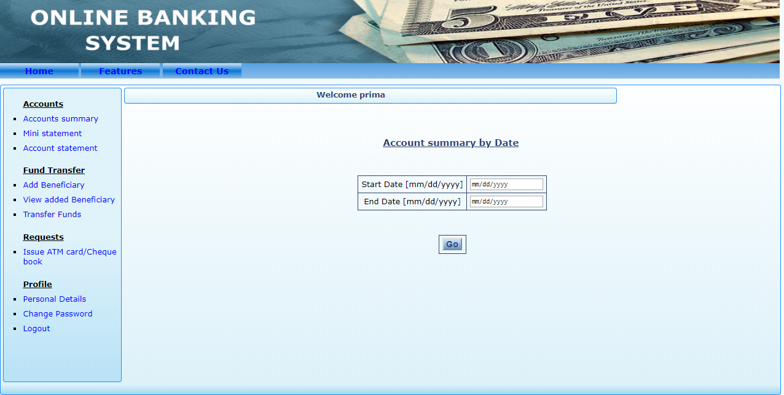

**Fig.21: Customer’s Account Statement**

**Customer’s Mini statement:** Here, customer can see mini account statement

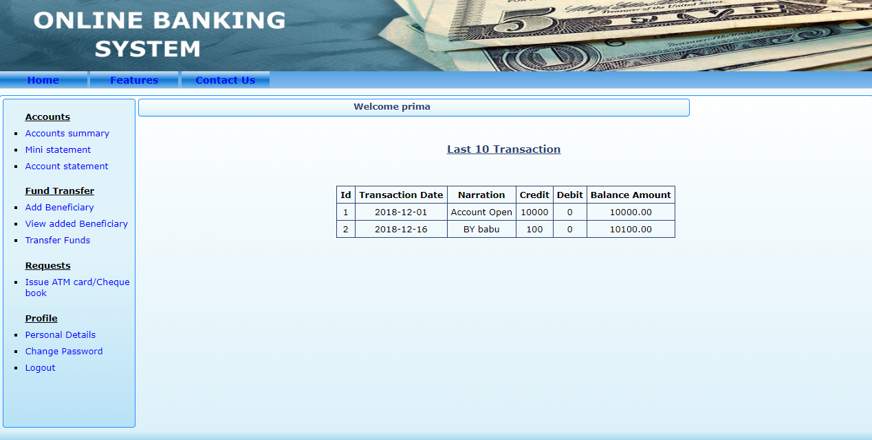

**Fig.22: Customer’s Mini Account statement**

**Customer add Beneficiary:** Here, customer can add beneficiary.

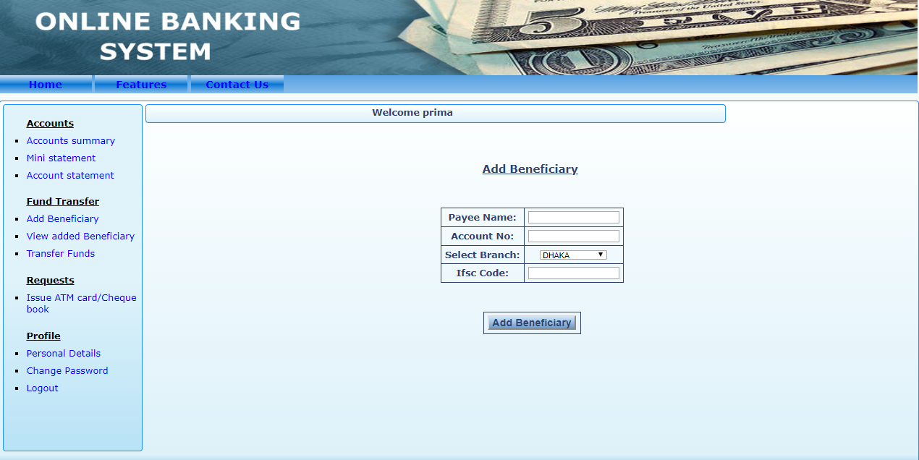

**Fig.23: Customer add Beneficiary**

**Fund Transfer by Customer:** From here, a customer can transfer fund to other account

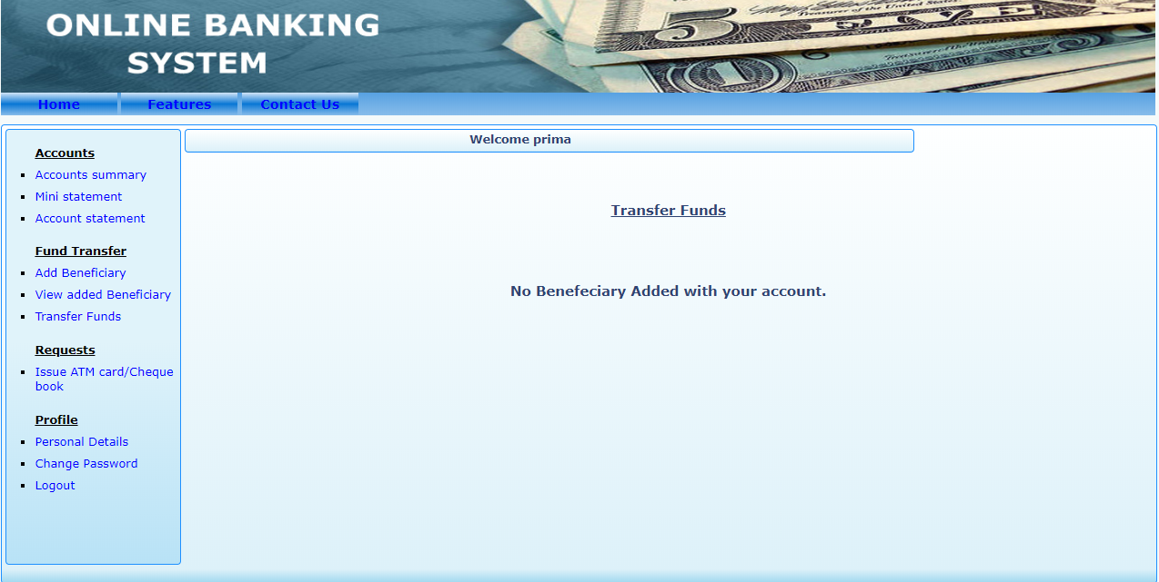

**Fig.24: Customer’s fund transfer**

**Customer view and delete Beneficiary**: From here, a customer can view or delete Beneficiary

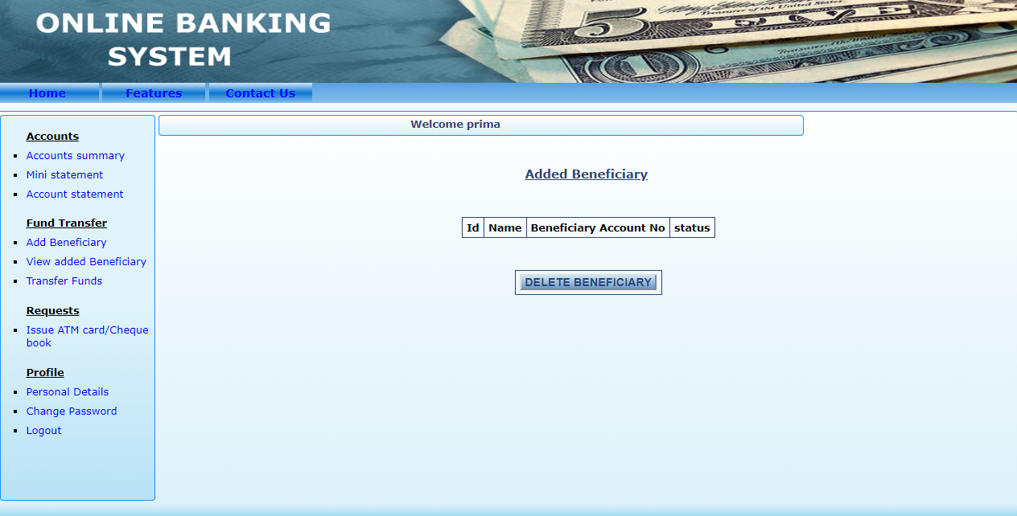

**Fig.25: Customer view or Delete Beneficiary**

**4.6.3 Staff Panel:**

**Staff Options:** This is staff homepage where a staff can see customers atm approval, customer approval request, cheque book request.

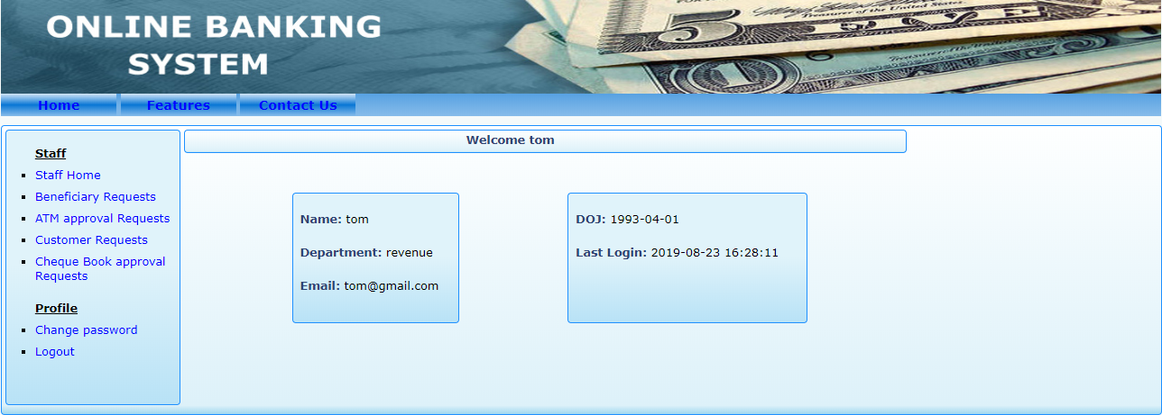

**Fig.26: This is a figure for staff option.**

**Staff Change Password: From, here staff can change account’s password**

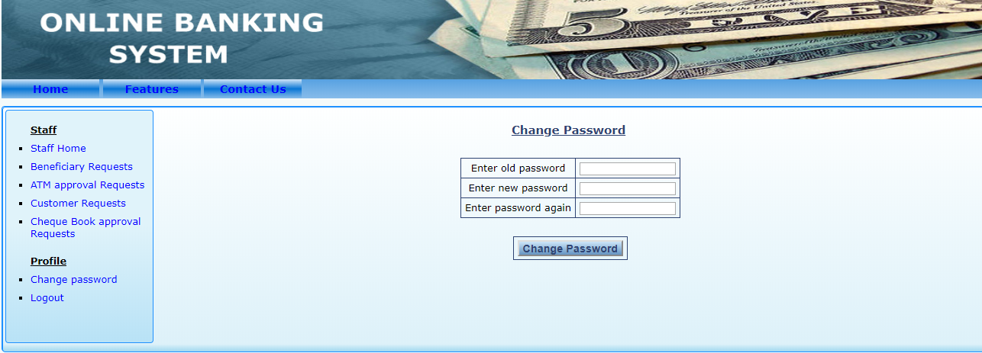

**Fig.27: Staff’s Password change**

**Staff approves Customer:** Here, a staff approves customer from request Quees.

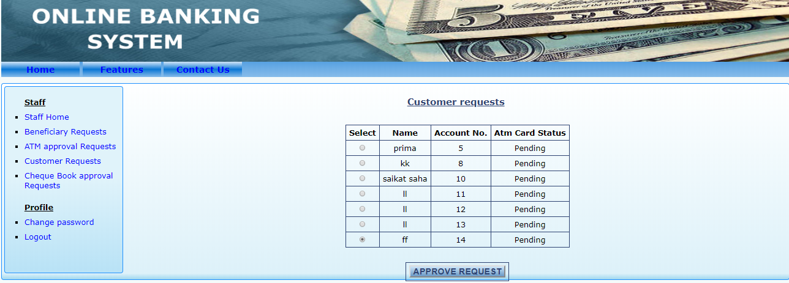

**Fig.28: Customer approve**

**Staff approval Customer atm:** Here, staffs approve customer atm.

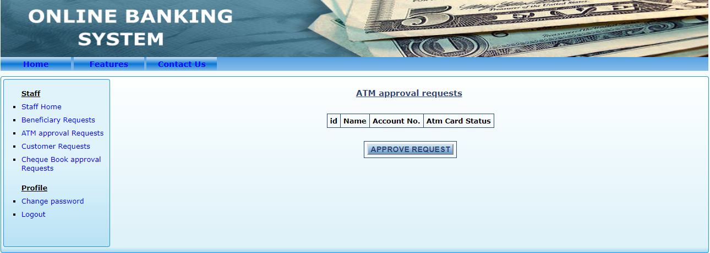

**Fig.29: Customer’s atm approval**

**Staff approval customer Beneficiary:** From, here a Beneficiary is approved by a staff.

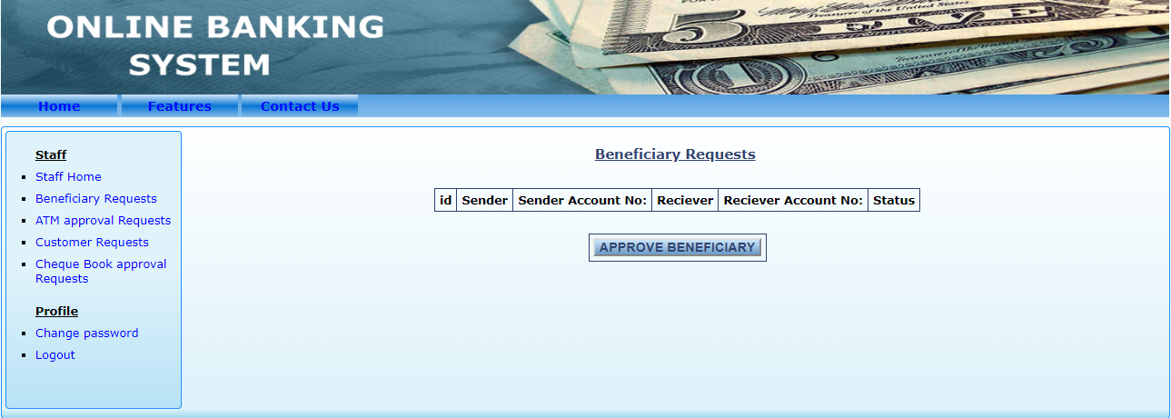

**Fig.30: Customer’s Beneficiary approval**

**Staff Approval Cheque Book:** Here, cheque book is approved.

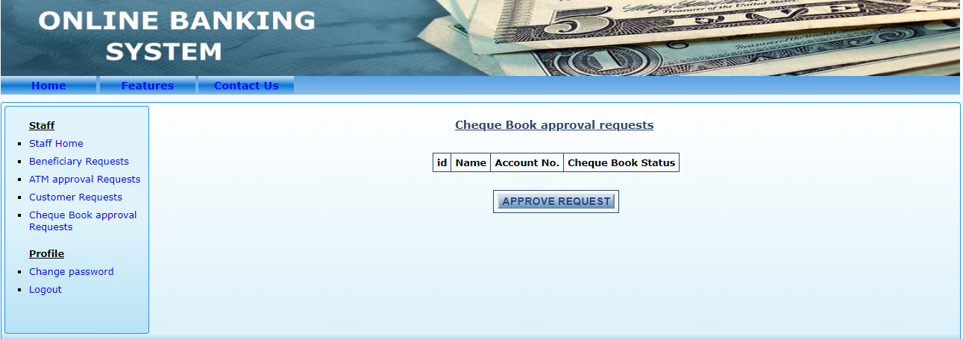

**Fig.31: Approval of cheque book**

|  |
| --- |
| **CHAPTER 5**: **LITERATURE STUDY** |

**5.1 Description of Similar Existing Systems:**

This section illustrates the existing systems or applications that we studied before developing this system. We have observed nine (9) systems for this purpose. Among them three(3) are for Banking Management System and five (6) are Others Management System which also relate with banking transaction as well those software can perform feature like pay from anywhere from customer bank account and so on. We have marked the features that they have and extracted the features with respect to the applications.

**List of Banking and Banking Related Management Systems:**

1. Traderoot Technologies.
2. Oracle Flexcube-Core Banking solution.
3. Altamira
4. IBS
5. ICS Bank
6. i-Mall
7. Kastle
8. Olympic Bank System.
9. Omni Enterprise

**5.2 Feature/performance Gap with Existing Systems:**

We have listed 12 features of Existing Systems. They are listed below:

1. Payment option through different sort of card like credit/master card etc.
2. Payment/transaction cancellation.
3. Customer details.
4. Monitoring operators.
5. Do transaction online.
6. Send money from one account to other account.
7. Pay any bills through their banking account.
8. Refund request
9. Customer, Admin & Staff have their own unique mail id and password.
10. Have record all transaction
11. Admin and staff can send notification for various update or notice

12. Customer can change their password and modified their profile also.

The important gap between existing system and our proposed system is customer’s own panel where he/she can see all the account related details and transaction history which is not possible for above mentioned systems. A customer can change his/her information from his/her own panel. The next gap is seeing account statement which is not available in the existing systems. Another gap is request for new cheque book online. In existing systems one need to go to bank and apply for a new cheque book. These are the gap of features or performance of existing systems and our proposed system.

**5.3 Comparison chart:**

**This is a chart for comparison of features between existing system and our proposed system**

|  |  |  |  |  |
| --- | --- | --- | --- | --- |
| Sl | Oracle Flexcube-Core Banking solution | Olympic Bank system | Sohoj Banking | Count |
| 1 | ✓ |  |  | 1 |
| 2 | ✓ |  |  | 1 |
| 3 | ✓ |  | ✓ | 2 |
| 4 | ✓ | ✓ | ✓ | 3 |
| 5 | ✓ | ✓ |  | 2 |
| 6 | ✓ |  | ✓ | 2 |
| 7 |  |  |  | 0 |
| 8 |  |  |  | 0 |
| 9 | ✓ |  | ✓ | 2 |
| 10 |  |  | ✓ | 1 |
| 11 |  | ✓ | ✓ | 2 |
| 12 |  |  | ✓ | 1 |
| TF | 7 | 3 | 7 | 17 |

Above this comparison chart we see that our system has some similarities and dissimilarities as well. There are several software in the market like as Oracle Flexcube-Core Banking solution, Olympic Bank system. We try to develop the system where we try to find out their development scope as well we implement our new feature as well.

**5.4 External Resources Required so Far:**

This project does not require any external human resources. We used information about existing Banking systems and Banking related management systems from the internet.

|  |
| --- |
| **CHAPTER 6**: **DEVELOPMENT PROCESS** |

**6.1 Methodology of Development:**

We used agile methodology to develop the system. Agile is an iteration based software development method. In agile method, we can fix error at any time and we can start and stop anywhere we needed. We used XP process model in the development of this system.

**6.2 Developed System Specification:**

|  |  |
| --- | --- |
| **Homepage(index)** | Login panel(customer,admin,staff),sign up. |
| **Admin** | Show profile,add customer,/staff, delete customer/stff, change password, profile edit,logout. |
| **Customer** | Show profile, can see account statement,mini statement, add beneficiary, apply for cheque/atm, transfer funds, edit profile, change password, logout. |
| **Staff** | Can see profile, approve atm/cheque, approve beneficiary, approve new customer request, change password, logout. |

|  |
| --- |
| **CHAPTER 7**: **PROGRESS SO FAR** |

**7.1 Discussion on outcome:**

We have done almost all features we wanted to implement in the system. The all features we sadded are working perfectly. We had an initial plan to develop a mobile application but at the end we could not develop the application. We have a plan to develop a mobile application for Android and IOS in near future.

**7.2 Performance Progress:**

We are getting maximum performance from the system so far. In testing the system fulfilled its performance requirement.

**7.3 Findings:**

The security of the system is still very vulnerable. We could not add OTP system for each transaction intended. We used email notification for successful transaction but SMS notification is more useful.

**7.4 Future Aspects**

1. Make more user friendly
2. Collect appropriate requirement
3. Make service faster
4. Can do transaction at any place.
5. Faster processing of information as compared to the current system
6. Faster update of the system.
7. Make more reliable and secure form compared to the current system.
8. Include more function and produce more widgets to the system
9. Can enhance the interface so that it looks more attractive and interactive.

**7.5 Conclusion**

“Sohoj Banking” is online based banking system which provides banking service on online. This system is user friendly, secure and accurate. It is much more efficient than manual banking transaction system. While working with the project we learnt many advantage and disadvantages of manual and online base banking system. Online Banking system and after going through it we understood the criteria for making software more demanding, set the fast error-handler for maintain error. We make the software more effective so that it can cope with the new and advanced technology. It’s a matter of joy and honor that we get the opportunity to work with the project and implemented the topic.

|  |
| --- |
| **CHAPTER 8**:**REFERENCES** |

1. https://www.globalbrandsmagazine.com/list-of-banking-software/
2. http://www.icsfs.com/en
3. http://www.icsfs.com/en/products/core-banking
4. https://legacy.imal.org/en/page/about-imal
5. http://www.imalpal.com/en/
6. httpes://security.kastle.com/
7. http://www.omni-enterprise.com/
8. http://www.infrasofttech.com/banking-products
9. http://www.oracle.com/us/industries/financial-services/046059.pdf
10. http://bankingsoftwareinfo.blogspot.com/
11. IEEE Software Engineering Standards Committee, “IEEE Std 830-1998, IEEE Recommended Practice for Software Requirements Specifications”, October 20, 1998
12. https://www.roberthalf.com/blog/salaries-and-skills/6-basic-sdlc-methodologies-which-one-is-best